**Creating Microservices for account and loan:**

AccountApplication:

package com.cognizant.account;

import org.springframework.boot.SpringApplication;

import org.springframework.boot.autoconfigure.SpringBootApplication;

@SpringBootApplication

public class AccountApplication {

public static void main(String[] args) {

SpringApplication.run(AccountApplication.class, args);

}

}

AccountController:

package com.cognizant.account.controller;

import org.springframework.web.bind.annotation.*;

*@RestController*

public class AccountController {

*@GetMapping*("/accounts/{number}")

public Account getAccountDetails(*@PathVariable* String number) {

return new Account(number, "savings", 234343);

}

static class Account {

private String number;

private String type;

private double balance;

public Account(String number, String type, double balance) {

this.number = number;

this.type = type;

this.balance = balance;

}

public String getNumber() { return number; }

public String getType() { return type; }

public double getBalance() { return balance; }

}

}

Application.properties: spring.application.name=account

Pom.xml:

<?xml version="1.0" encoding="UTF-8"?>

<project xmlns="http://maven.apache.org/POM/4.0.0" xmlns:xsi="http://www.w3.org/2001/XMLSchema-instance"

xsi:schemaLocation="http://maven.apache.org/POM/4.0.0 https://maven.apache.org/xsd/maven-4.0.0.xsd">

<modelVersion>4.0.0</modelVersion>

<parent>

<groupId>org.springframework.boot</groupId>

<artifactId>spring-boot-starter-parent</artifactId>

<version>3.5.3</version>

<relativePath/> <!-- lookup parent from repository -->

</parent>

<groupId>com.cognizant</groupId>

<artifactId>account</artifactId>

<version>0.0.1-SNAPSHOT</version>

<name>account</name>

<description>Demo project for Spring Boot</description>

<url/>

<licenses>

<license/>

</licenses>

<developers>

<developer/>

</developers>

<scm>

<connection/>

<developerConnection/>

<tag/>

<url/>

</scm>

<properties>

<java.version>17</java.version>

</properties>

<dependencies>

<dependency>

<groupId>org.springframework.boot</groupId>

<artifactId>spring-boot-starter-web</artifactId>

</dependency>

<dependency>

<groupId>org.springframework.boot</groupId>

<artifactId>spring-boot-devtools</artifactId>

<scope>runtime</scope>

<optional>true</optional>

</dependency>

<dependency>

<groupId>org.springframework.boot</groupId>

<artifactId>spring-boot-starter-test</artifactId>

<scope>test</scope>

</dependency>

</dependencies>

<build>

<plugins>

<plugin>

<groupId>org.springframework.boot</groupId>

<artifactId>spring-boot-maven-plugin</artifactId>

</plugin>

</plugins>

</build>

</project>

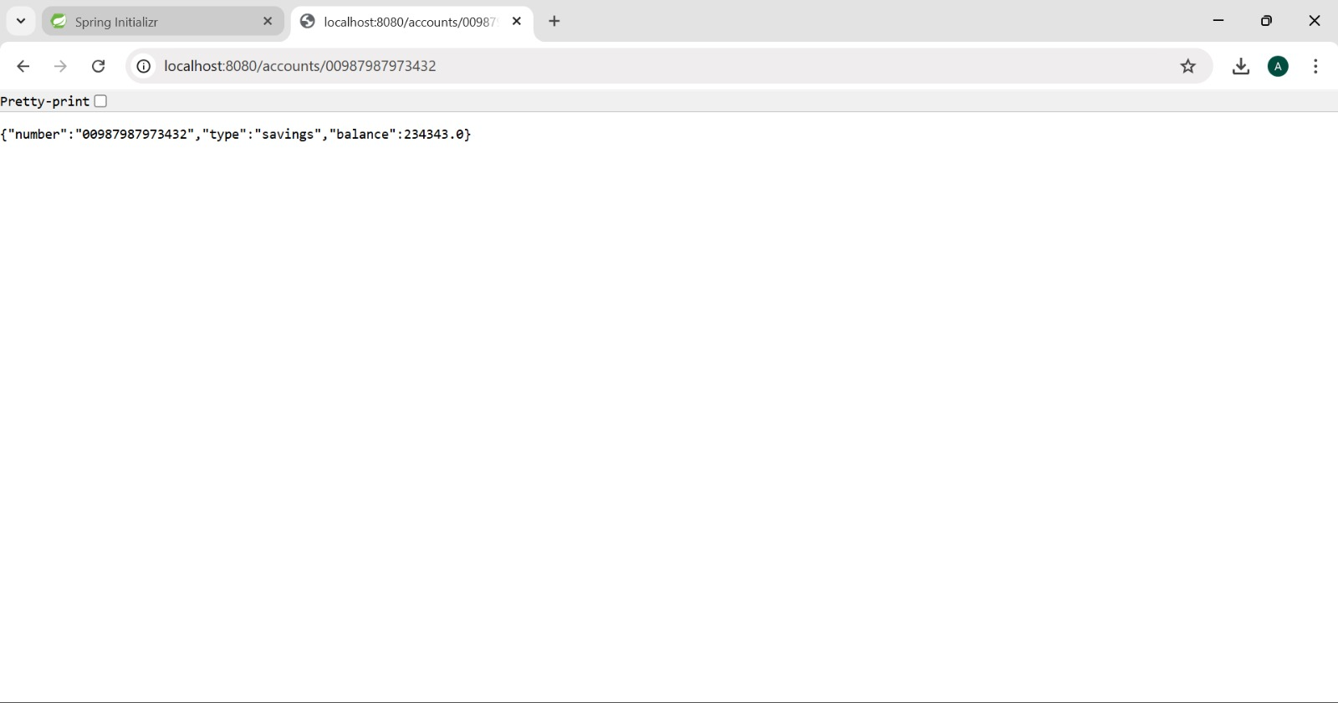  
  
  
LoanApplication:  
package com.cognizant.loan;

import org.springframework.boot.SpringApplication;

import org.springframework.boot.autoconfigure.SpringBootApplication;

@SpringBootApplication

public class LoanApplication {

public static void main(String[] args) {

SpringApplication.run(LoanApplication.class, args);

}

}  
LoanController:

package com.cognizant.loan.controller;

import org.springframework.web.bind.annotation.*;

*@RestController*

public class LoanController {

*@GetMapping*("/loans/{number}")

public Loan getLoanDetails(*@PathVariable* String number) {

return new Loan(number, "car", 400000, 3258, 18);

}

static class Loan {

private String number;

private String type;

private double loan;

private int emi;

private int tenure;

public Loan(String number, String type, double loan, int emi, int tenure) {

this.number = number;

this.type = type;

this.loan = loan;

this.emi = emi;

this.tenure = tenure;

}

public String getNumber() { return number; }

public String getType() { return type; }

public double getLoan() { return loan; }

public int getEmi() { return emi; }

public int getTenure() { return tenure; }

}

}

Application.properties:

spring.application.name=loan

server.port=8081

pom.xml:

<?xml version="1.0" encoding="UTF-8"?>

<project xmlns="http://maven.apache.org/POM/4.0.0" xmlns:xsi="http://www.w3.org/2001/XMLSchema-instance"

xsi:schemaLocation="http://maven.apache.org/POM/4.0.0 https://maven.apache.org/xsd/maven-4.0.0.xsd">

<modelVersion>4.0.0</modelVersion>

<parent>

<groupId>org.springframework.boot</groupId>

<artifactId>spring-boot-starter-parent</artifactId>

<version>3.5.3</version>

<relativePath/> <!-- lookup parent from repository -->

</parent>

<groupId>com.cognizant</groupId>

<artifactId>loan</artifactId>

<version>0.0.1-SNAPSHOT</version>

<name>loan</name>

<description>Demo project for Spring Boot</description>

<url/>

<licenses>

<license/>

</licenses>

<developers>

<developer/>

</developers>

<scm>

<connection/>

<developerConnection/>

<tag/>

<url/>

</scm>

<properties>

<java.version>17</java.version>

</properties>

<dependencies>

<dependency>

<groupId>org.springframework.boot</groupId>

<artifactId>spring-boot-starter-web</artifactId>

</dependency>

<dependency>

<groupId>org.springframework.boot</groupId>

<artifactId>spring-boot-devtools</artifactId>

<scope>runtime</scope>

<optional>true</optional>

</dependency>

<dependency>

<groupId>org.springframework.boot</groupId>

<artifactId>spring-boot-starter-test</artifactId>

<scope>test</scope>

</dependency>

</dependencies>

<build>

<plugins>

<plugin>

<groupId>org.springframework.boot</groupId>

<artifactId>spring-boot-maven-plugin</artifactId>

</plugin>

</plugins>

</build>

</project>

